SKU CRUD and Order Process:

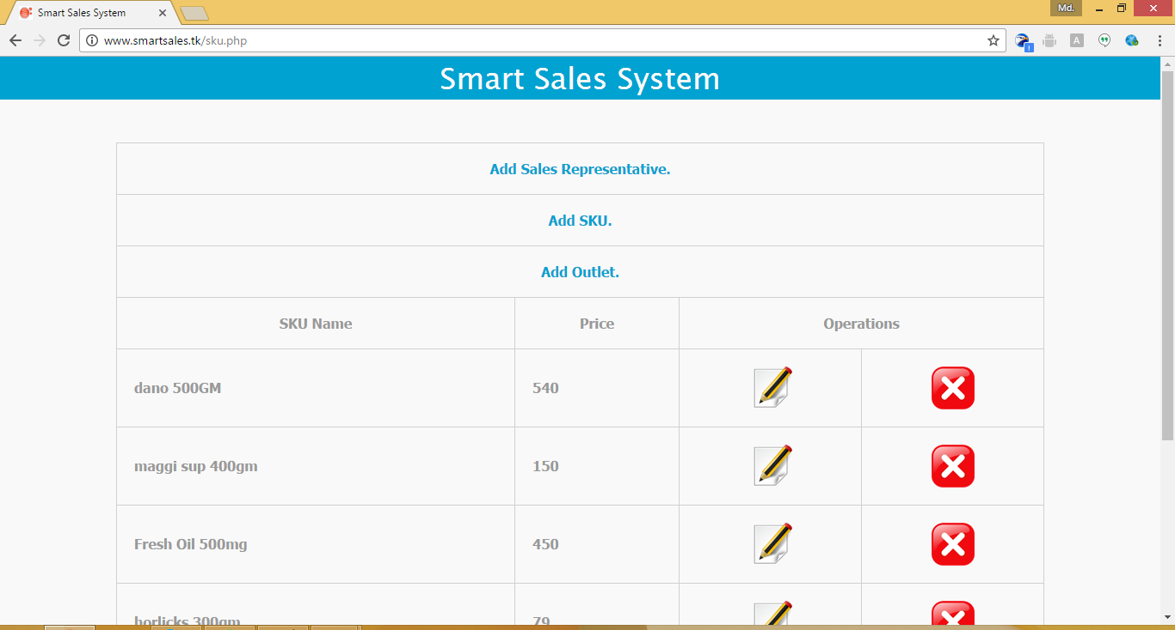

Type SKU Name and Price then Click on Save

To Create a New Product click on Add SKU

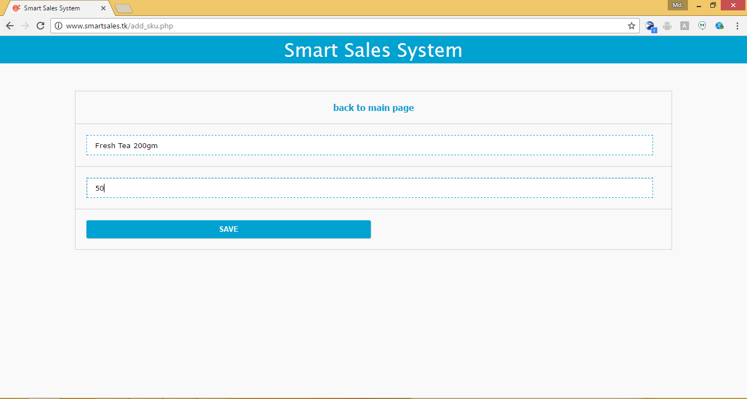

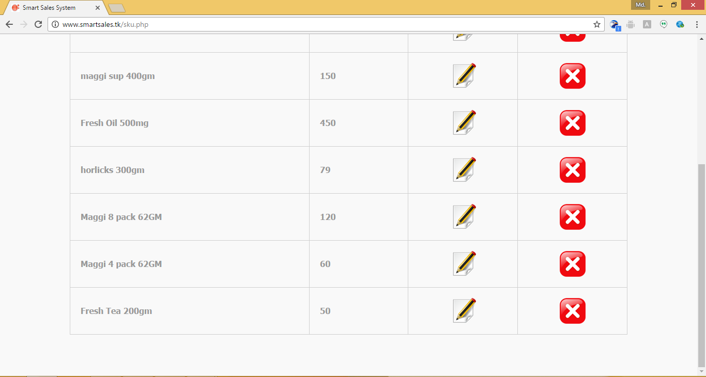

Update SKU Information

View SKU Information

Delete SKU Information

Login On Assigned Sales Representative

Sales Representative Routes Outlet List For Sales order

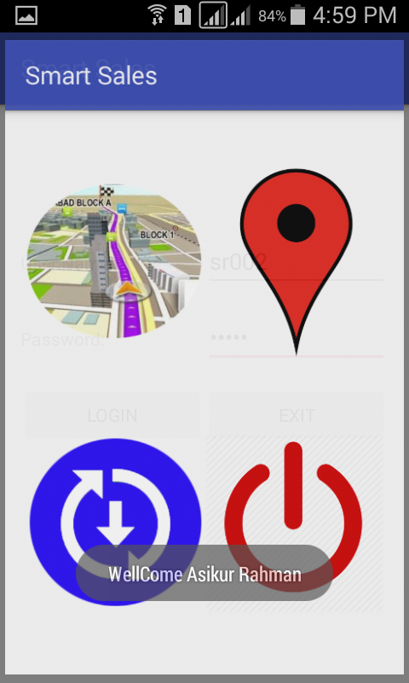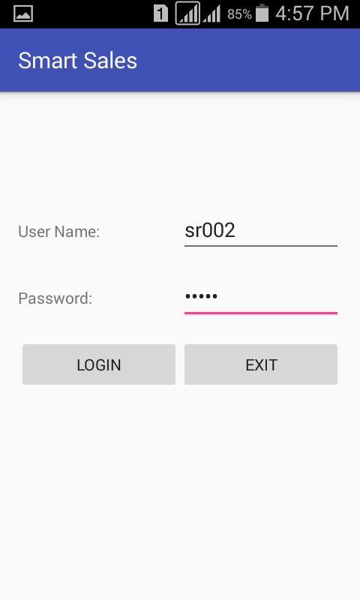

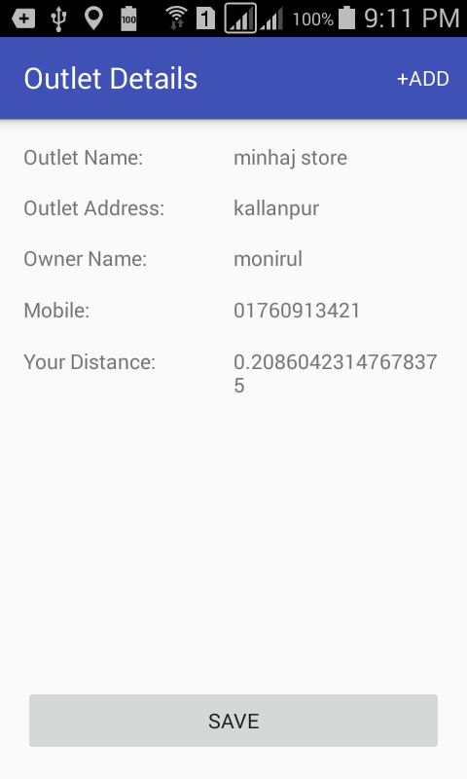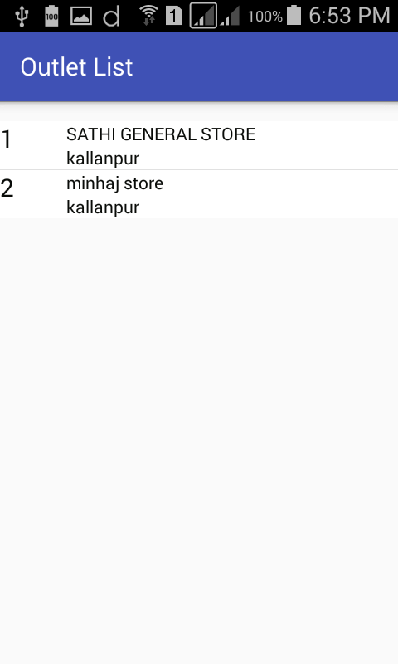

To View Outlet Details and Take order click on it

To Take Order Click +add

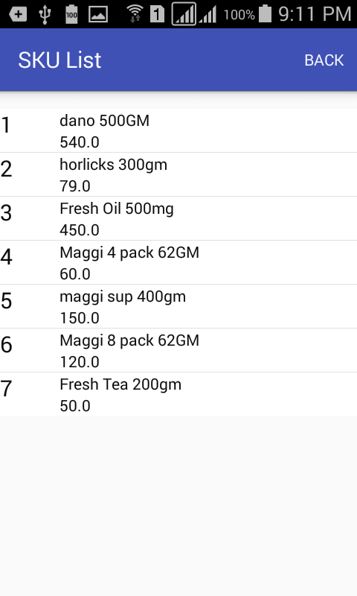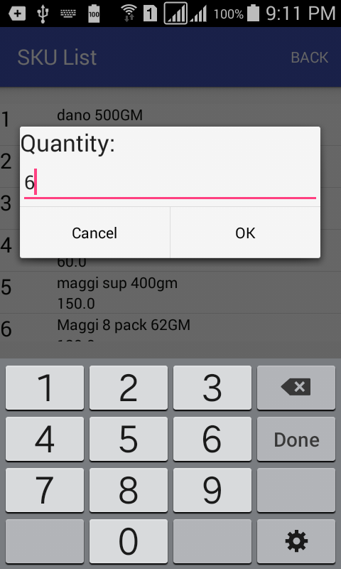

Sales Reprehensive Distance form Outlet

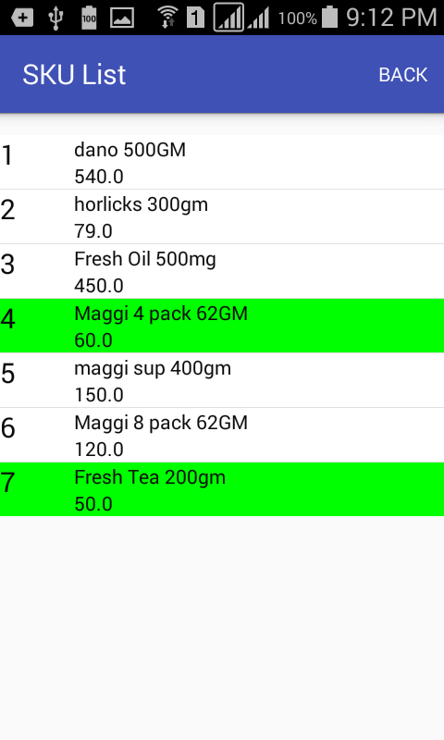

Click on BACK Button To See all order List

Type Quantity

Ordered SKU will be green color

Click on SKU to Take Order

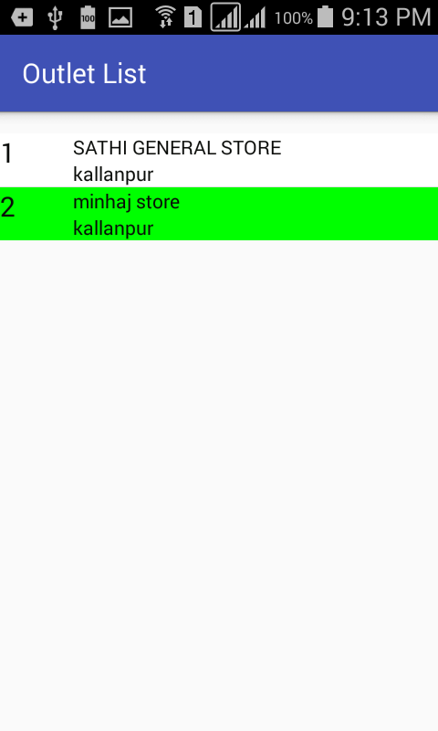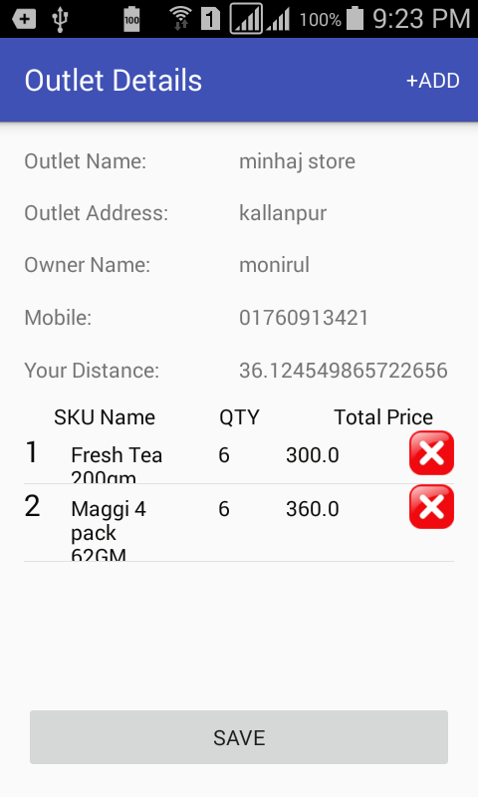

Ordered Outlet will be Green Color

To Cancel order click on Delete

To Send Order on Server Click on Save

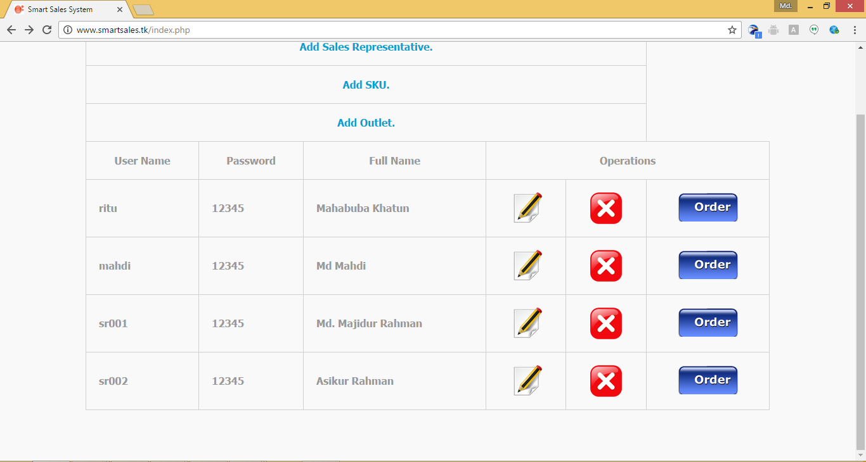

To See Sales Representative wise Order Click on Order button

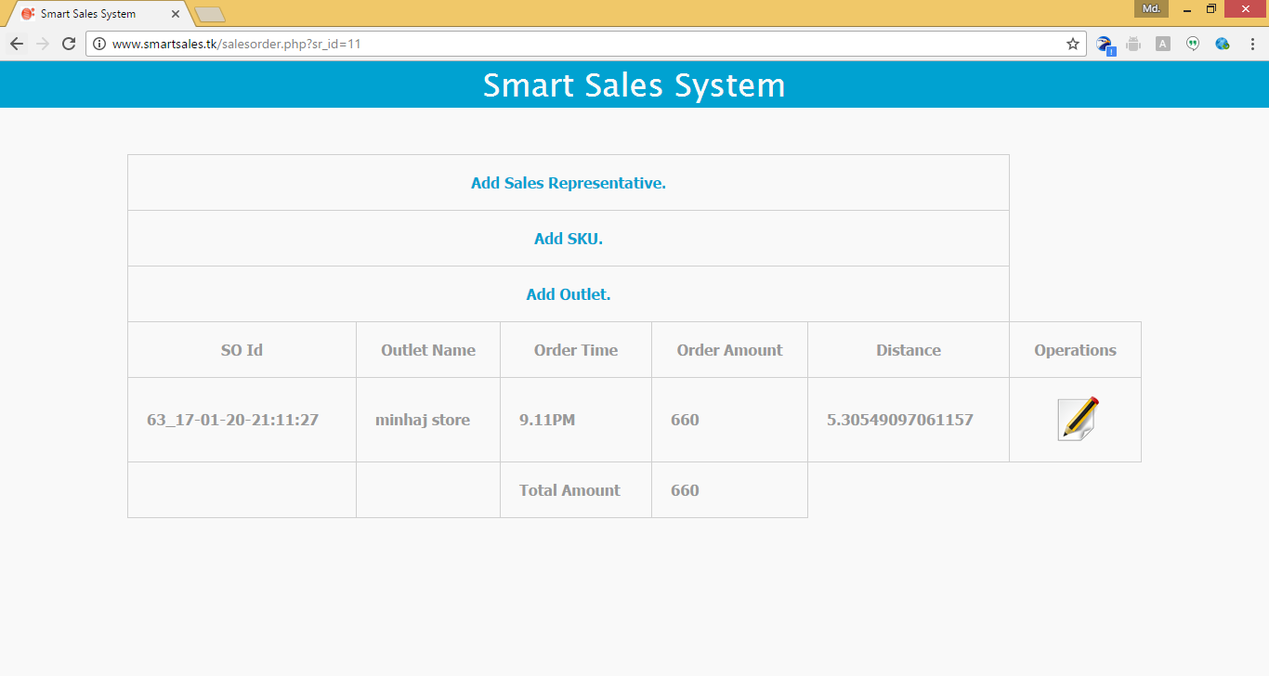

Order Time

Order ID and Outlet Name

Sales Reprehensive Distance form Outlet

SKU Wise Details View for Order

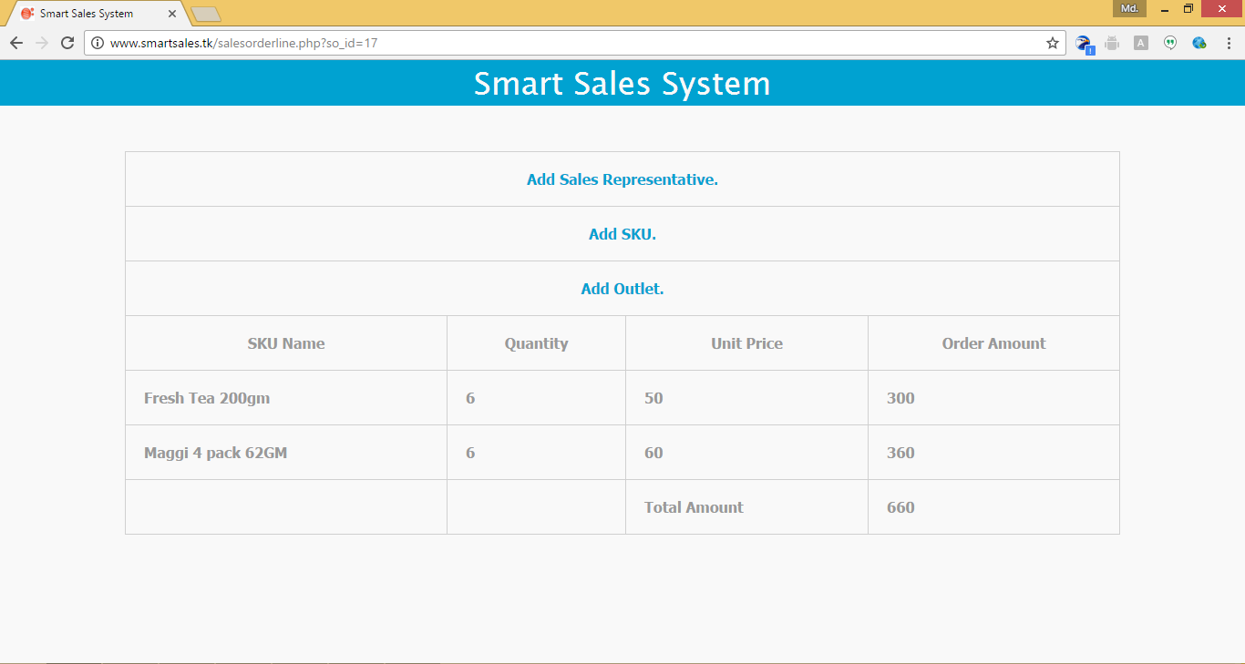

Order Details View